The 2016

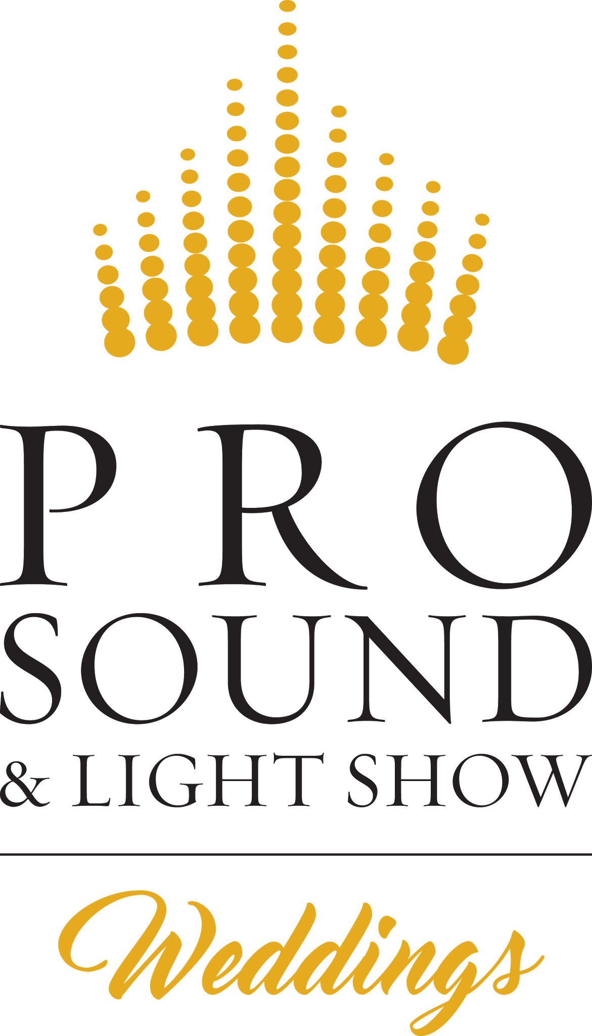
Week Long
BLACK
FRIDAY
SALE
Until 4PM, Friday, November 25th, 2016

www.pslsblackfriday.com

Greetings and thank you for registering for our Black Friday Event Sale Event!

My name is Aaron Abramson and I am the Chief Entertainment Officer at Pro Sound & Light Show. We have been helping thousands of happy brides & grooms celebrate their weddings for the past 25 years, and are the largest, most award winning entertainment company in the area. Striving to provide the best and most unique Disc Jockey, Master of Ceremonies, Event Lighting, and Photo Cube services.

The sale this week is one of the few times ever that we are running a promotion of this magnitude. We are offering discounted prices across the board for our services. We are doing this for 2 reasons. First, we have a few open dates next year that we would like to fill. Second, we are testing customer response to a few of the price points we are offering. I can assure you that during this event we are offering the LOWEST PRICES EVER on our services. In fact, prior to January 1st, we are restructuring our prices and packages which will result in an increase in pricing for many services (it has been a while since we have increased our rates and our costs and quality of services have gone up).

A few warnings about the sale
- Sale prices are for new bookings only. If you are an existing customer, you may add-on sale items to your package but cannot partake in offers for anything you already have booked.
- Sale prices are subject to availability. Simply put, we are already fully booked for many dates. If we are not available, we will promptly refund your money for any sale purchase and notify you within 48 hours (probably sooner).
- Quantities are limited. In this sale flyer, you can see how many of each item will be available at the discounted rate. Please note that our online system may allow bookings beyond those quantities and we will back out those orders within 24 hours. We do this as the system cannot tell what dates are available and which ones are full. Please do not get overly excited until we confirm that your booking has been finalized.
- Sale prices require payment in full.

I truly hope that you are able to get in on these awesome deals and that we will be working together on your wedding or special event in the near future.

Best Wishes,
Chief Entertainment Officer of Pro Sound & Light Show

LIMITED AVAILABILITY
To provide high quality service, we have a limit of 3 Diamond DJs booked per date.
With a maximum of 10 DJ systems total to be booked per date.
The following dates have limited availability:

SOLD OUT OF DIAMOND DJs ON
May 20th, 2017 - 3 Professional DJs left
August 5th, 2017 - 4 Professional DJs left
September 9th, 2017 - 2 Professional DJs left
September 16th, 2017 - 3 Professional DJs left
September 23rd, 2017 - 3 Professional DJs Left

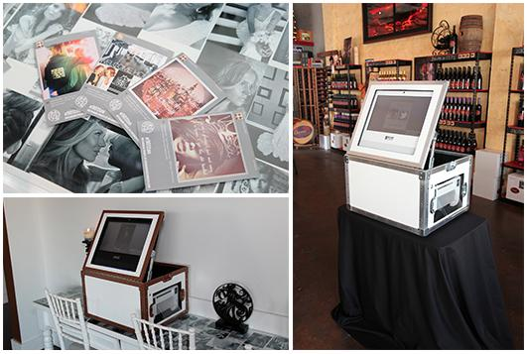
Photo Cube: Social Media #Hashtag Print Station

We are proud to offer something NEW when it comes to fun & unique photo booth ideas for events. The Photo Cube is a self contained social media #hashtag print kiosk that automatically downloads and prints all of the photos taken by your guests and posted to Instagram or Twitter. With 100’s of camera phones taking pictures all throughout the day, now you have a fun & entertaining way to experience, share & keep those pictures.

Black Friday Sale Price: Without DJ Service: 697 (save $302)
Added to DJ Service: 497 (save $502)
All Event Unlimited Print Package: Normally $999
- Complete coverage of your event (up to 10 hours) with unlimited prints
- Photo Cube Attendant to help guests
- You choose the style of print
- Free Local Delivery within 25 miles of Duluth, MN
- Free flash drive with copies of every photo printed.
- Includes 2 selfie sticks for guests to use
- Includes 2 iPod Touch’s for guest use

Photo Cube Testimonial:

Thank you for suggestion the photo cube. Although we have never thought of using the Photo Cube, this was one of our greatest joys at our wedding. Our guest have so much fun using their own phones and the selfie sticks for taking pictures and the ease of transferring to the photo cube allowed the guest to take a piece of history with them. With each picture guest loved, they could print their own polaroid and place another polaroid in our wedding photo book that was provided by you, what a very nice surprise. The photo book is now set up in our living room for other to view. Not only was this a hit and all the items you provided with the photo cube, I would strongly suggest any outing to use this device. Our next big family outing will have this Photo Cube again.
Again, Thank you expert service and professional advice.
Jason & Molly Eastman (newlyweds)

SEE THE PHOTO CUBE IN ACTION: http://www.pro-1.com/l/photo-cube/
Wedding DJ Entertainment Services

Wedding Packages vs. Custom Quotes
Every year we evaluate the most commonly requested DJs, services & add-ons to determine what our most popular packages are. We currently have 3 options with the most popular add-ons and services already bundled together for you. These packages can be customized by adding-on extra services for an additional fee, however, removing a service from a package will not reduce the price. If you’re looking for something that doesn’t quite fit within our package bundles, call us at 888-347-5562 for a custom quote.

Experience Level is the Biggest Difference Between DJ Packages

Each and every Pro Sound & Light Show Wedding DJ must exceed our high standard of quality. Newly hired DJs, even if they have previous DJ experience, must pass our Professional Wedding DJ & Diamond MC Training Programs. These comprehensive programs cover all aspects of a wedding reception, including but not limited to: Music Programing & Theory, Professional Audio Engineering, Lighting Control & Design, Customer Service, Wedding Ceremonies, Grand March & Bridal Party Introductions, Toast & Speech Introductions, Cake Cutting Ceremonies, Introducing the First Dance & Other Spotlight Dances, Garter & Bouquet Toss, Dollar Dance, appropriate Games, Interactions, & Transitions.

DJ Experience Levels
Professional DJ - Completed our Professional DJ Training Program, and has completed our Shadowing & Assisting program, learning from our top-rated Diamond DJs.

Diamond DJ - Has been with the company an average of 3 years or more. Passed our Diamond MC Training Program, and maintains a 4.5 out of 5 star review rating.

Signature DJ - Has been a Diamond DJ for at least 2 years, and have performed a minimum of 200 weddings. Has also received additional training at workshops from industry leaders.

Wedding DJ Entertainment Packages

Diamond DJ Package
Unlimited Reception Planning, Coordination & Entertainment: Normally $1950
Black Friday Sale Price: 1547 (save $403)
- Unlimited Hours of Reception Entertainment
- Unlimited Planning Meetings
- Reception Planning Services & Day of Reception Coordination Services
- Top Rated Diamond DJ
- Professional Sound System
- Dance Floor Lighting
- Ceremony Sound & Coordination Included
- Money Back Satisfaction Guarantee

Professional DJ Package
Standard Wedding DJ Planning, Coordination & Entertainment: Normally $1350
Black Friday Sale Price: 947 (save $453)
- 8 Hours of Entertainment (including cocktail/dinner music)
- Unlimited Planning Meetings
- Reception Coordination Services
- Professionally Trained DJ
- Professional Sound System
- Dance Floor Lighting
- Money Back Satisfaction Guarantee

Essential DJ Package
Basic Wedding DJ Entertainment: Normally $1150
Black Friday Sale Price: 847 (save $303)
- 5 Hours of Entertainment (including cocktail/dinner music)
- Professionally Trained DJ
- Professional Sound System
- Dance Floor Lighting

For more details on Disc Jockeys, please visit: www.pro-1.com

All Inclusive Signature VIP Experience
This is our outside the box, no-frills, no cookie-cutter wedding experience. Our staff will use many unique and totally customized enhancements to make your wedding unlike any you or your guests have ever experienced. We will use all of our vast wealth of both technical and personnel resources available to us to create a dream wedding reception that no other company can dream of pulling off. The bottom line is that all your family, friends, guests, and loved ones that have traveled great distances, at considerable expense, to spend their day with you will have an immense amount of fun!

Signature DJ Service: Normally $2750
- Exclusive Signature DJ
- Fully Customized lighting production (up to a $4000 value)
- Intelligent Lighting Design
- Full Room Uplighting
- “Your Name In Lights” Custom Monogram
- Dancing On A Cloud
- Unlimited Hours of Reception Entertainment
- Unlimited Reception Planning Meetings
- Reception Planning & Day-of Coordination Services
- Premium Sound System
- Dance Floor Lighting
- Money-Back Satisfaction Guarantee

Black Friday Sale Price: 2247 (save $503)
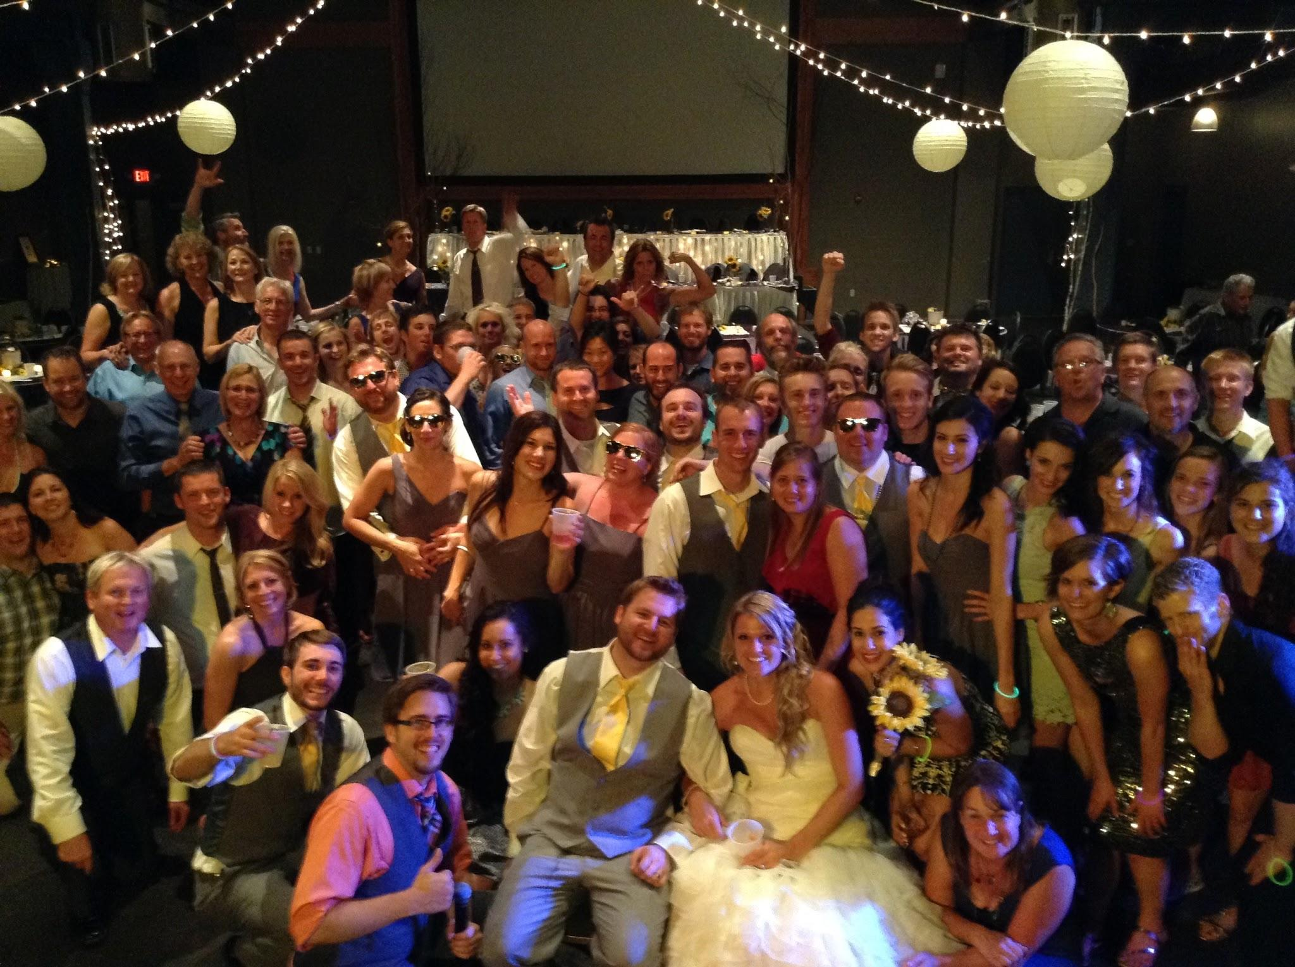

Event Lighting Rental Services

We have found custom lighting design to be an area that can highly impact both the look and mood of your wedding. Our company offers more lighting options and unique features, than any other DJ service in the area. We can custom design décor lighting to fit both your facility and your budget.

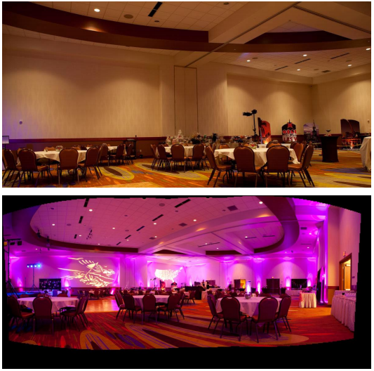

8 LED Rental Package (any color you want!)
Normally $299
Black Friday Sale Price: 149 (save $150)

Add-ons & Upgrades

Customize your entertainment experience with any of our great options

On-Site Ceremony Music & Microphones: Normally $399
(Includes Unlimited Music Time)
Black Friday Sale: 199 (save $200)

Unlimited Reception Music Hours: Normally $199
Black Friday Sale: 99 (save $100)

Love Story: Normally $399
Black Friday Sale: 199 (save $200)

Dancing on a Cloud: Normally $399
Black Friday Sale: 299 (save $100)

Custom Monogram “Your Name In Lights”, Normally $299
Black Friday Sale: 149 (save $150)

How to get in on the sale:

- Stop by our office during business hours before 4PM Friday November 27th, 2015
- Go to www.pslsblackfriday.com to order online
- Scan & Email the order form page to yourdj@pro-1.com
- Call our office at 888-347-5562 to order over the phone

Our address is:
Pro Sound & Light Show
350 Garfield Ave, Suite 5
Duluth MN 55802.

Duluth (218) 722-1355
Twin Cities (612) 724-7377
St. Cloud (320) 252-5310
Brainerd (218) 828-6266
Toll Free (888) 347-5562

All services booked with this offer are non-cancellable, non-refundable. All payments are final once availability is confirmed.

ALL ORDERS will be treated as first-come, first-served in accordance with the timeframes set above. We WILL NOT honor these prices any other time except black Friday until the listed quantities run out. Prices valid for NEW BOOKINGS ONLY and may not be combined with any other discount or offer. Void where prohibited by law.
Black Friday SALE Order Form:

For fastest service please print this page and bring it with you to our office already filled out. You may also email this form to yourdj@pro-1.com or call us at 888-347-5562 to order over the phone.

This order form does not constitute a legal agreement and is subject to verification of availability and all other terms of offer. Simply stated, sale booking is not confirmed until we personally contact you with personal confirmation of booking. LIMIT ONE of each item per event.

 | Normal | Sale | Qty Avail | Booking Total
Photo Cube Without DJ Service | $999 | 697 | 7
Photo Cube added to DJ Service | $999 | 497 | 4
Diamond DJ Package | $1950 | 1547 | 5
Professional DJ Package | $1350 | 947 | 8
Essential DJ Package | $1150 | 847 | 7
Signature DJ Service | $2750 | 2247 | 2
8 LED Uplights | $299 | 149 | 10
On-Site Ceremony | $399 | 199 | 8
Unlimited Music Time | $199 | 99 | 10
Love Story | $399 | 199 | 10
Video Love Story | $349 | 249 | 5
Dancing on a Cloud | $399 | 299 | 4
Custom Monogram | $299 | 149 | 10
Brides Name:______________________________________________________ |  |  |  | Total Order Cost
Payment Information (credit cards only for email, and online)

_________________________________________ ________________________________________ _____________
Name on Card (please print) Card Number (Visa, MC, Disc, AmEx) Exp (MM/YY)

________
CSC (3 or 4 digits)

________________________________________________________________ _____________________ _____ ___________
Billing Address (must match card) City State Zip

_______________ ________________________ _____________________________________
Event Date Your Phone Number Your Email Address

___________________________ ___________ ______ __________________________________ ____________
Event Venue City State Your Signature Todays Date
I authorize Pro Sound & Light Show to charge my credit card for the full amount of the quoted sale price.
We will contact you within 1 week for all other event details and specifications.

